On-the-Job Training Schedule of ACTIVITIES/TASKS
Name of Trainee: Sean Austin Alarcon
Department: IT Development Team
Week 2: June 29 - July 5 2025
Sunday  29 - June | Monday  30 - June | Tuesday  1 - July | Wednesday  2 - July | Thursday  3 - July | Friday  4 - July | Saturday  5 - July | TASK # | Remarks
1-8pm  7hrs | 10-3am  5hrs |  |  |  |  |  | TASK 1 | Completed
 |  | 2-5pm  3hrs |  |  |  |  | TASK 2 | Completed
 |  |  |  | 12-3pm  4hrs | 9-12pm  4hrs |  | TASK 3 | Completed
 |  |  |  |  | 1-4pm  3hrs | 1-3pm  2hrs | TASK 4 | Completed
 |  |  |  |  |  | 3-6pm  3hrs | TASK 5 | Completed
Total Hours Rendered: 31 Hrs
On-the-Job Training ACCOMPLISHMENT REPORT

Week 1: June 22 - June 28 2025
TASK | KEY TASKS (ACTIVITIES) | ACTUAL ACCOMPLISHMENT/OUTPUT | IMMEDIATE SUPERVISOR
TASK 1 | Chapter 1 Draft | 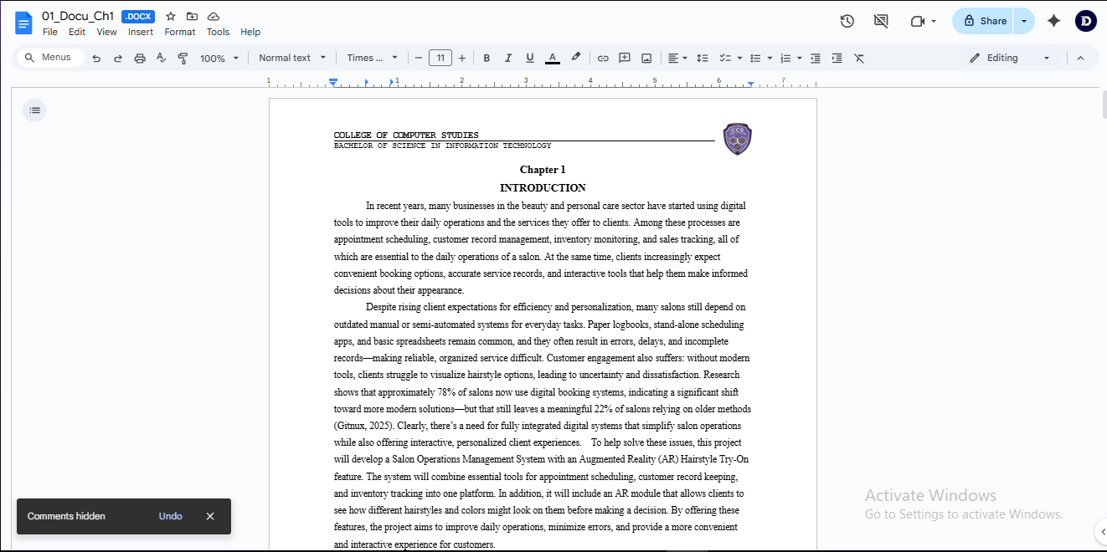 | Ms. Lucille M Republo
TASK 2 | Meeting for System Planning | 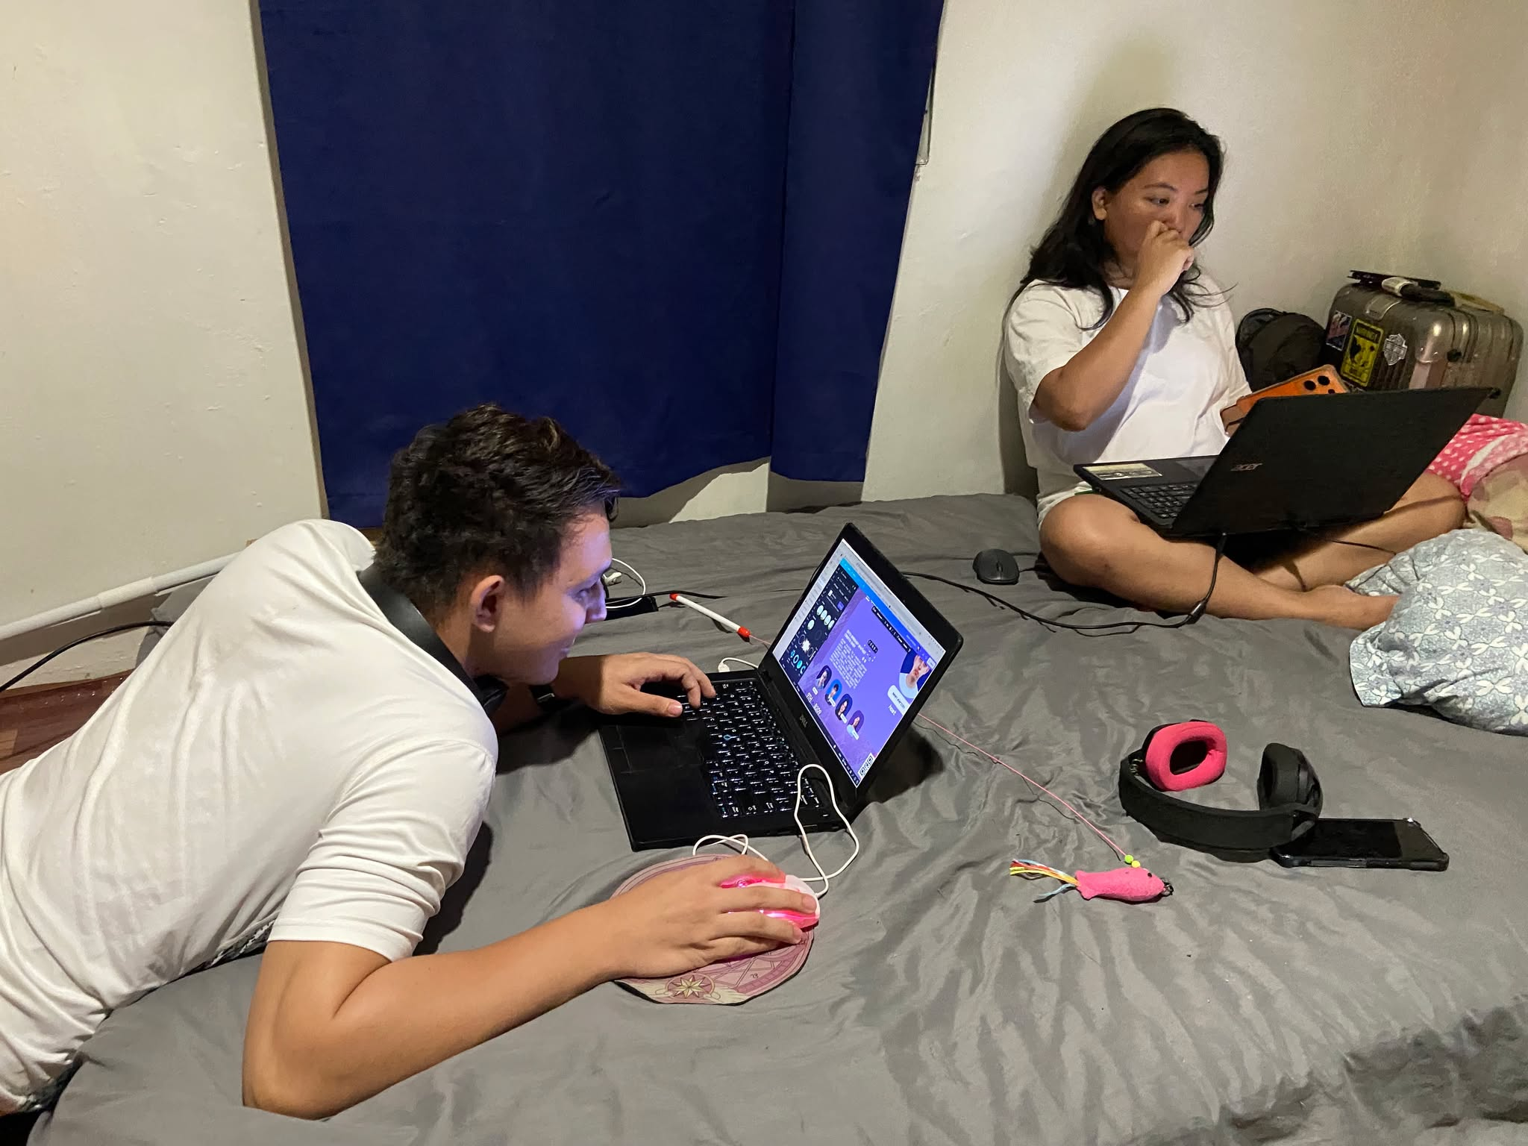 | None
TASK 3 | Business/ System Process Flowchart Creation  (Brainstorming) | 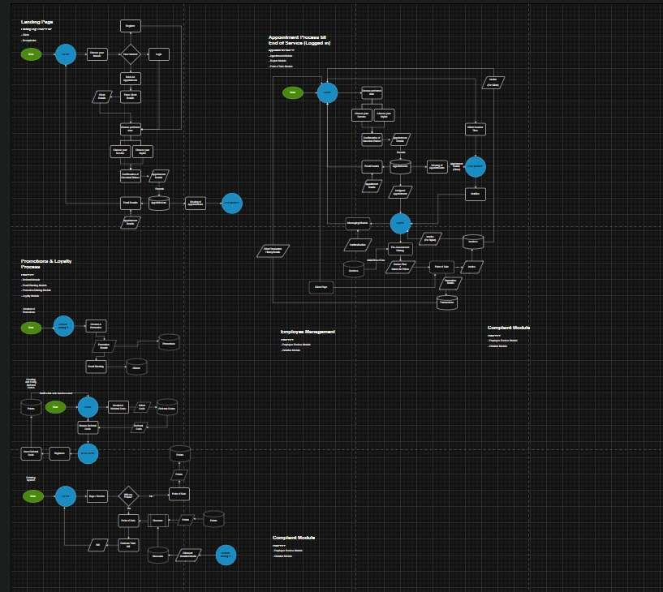 | None
TASK 4 | Initial System UI Prototype (For Planning) | 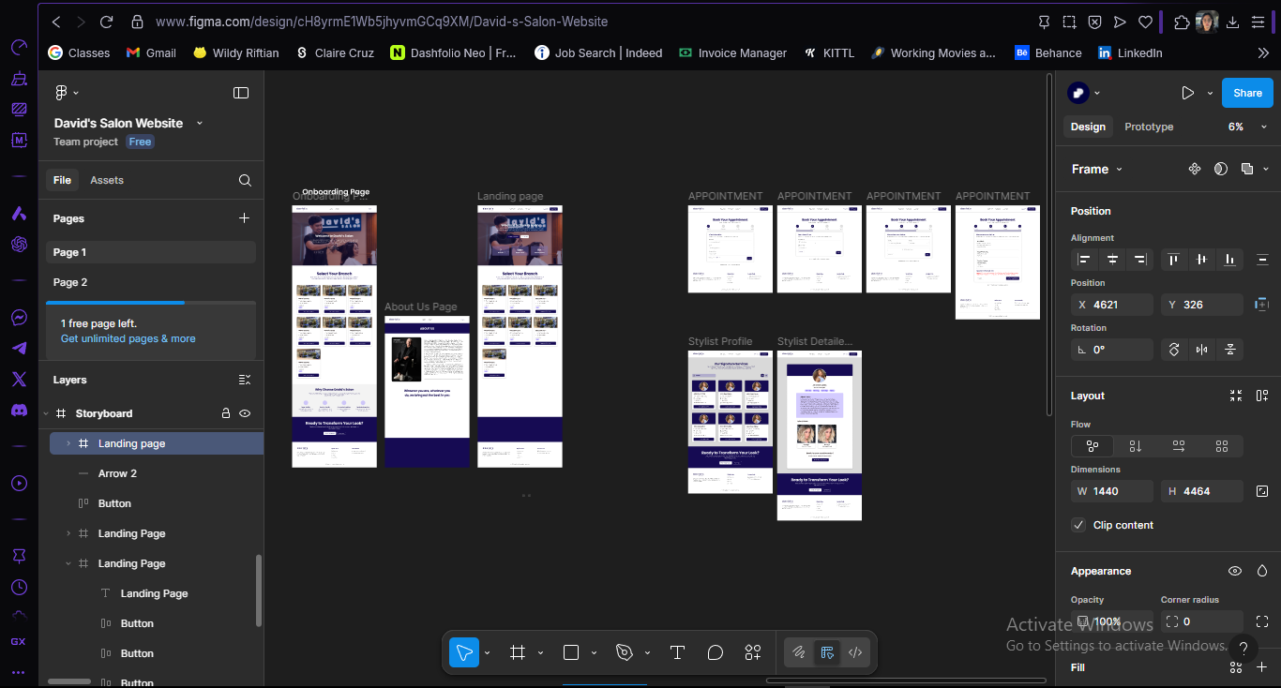 | None
TASK 5 | Chapter 1 Draft Revision | 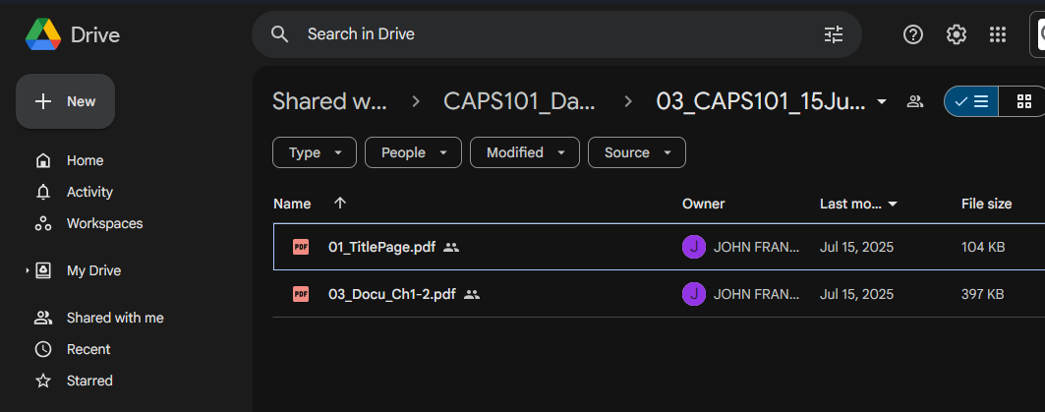 | None

Evidences/ Attachments:
